Quiz 1 ***(CSE331L.7 – Asif Ahmed Neloy_Summer’20)***

Department of Electrical and Computer Engineering

School of Engineering and Physical Sciences

North South University, Bashundhara, Dhaka-1229, Bangladesh

*Time 20 minutes, Marks 20 (You need to answer all questions).*

***Name -***

***ID -***

1. **Why it is never a good idea to store any data in the segment registers?[5]**

To speed up processor operations it includes some internal memory locations which are known as registers. In segment register data is stored but the memory doesn’t have the direct access to it.

1. **Write a program in Assembly language that will add 4 integer number (1,2,2,1) using only AX register and Store the result in the AX register.**

org 100h

MOV AX, 01

MOV BX, 02

MOV CX, 02

MOV DX, 01

ADD AX,BX,CX,DX; AX=AX+BX+CX+DX

**ret**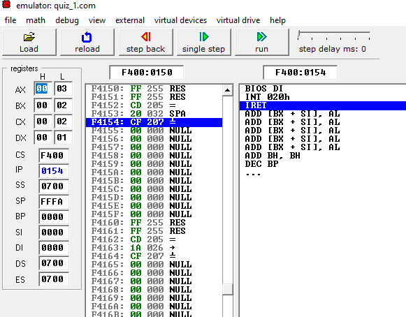

**End**